Question 1: Choose two of the sorting algorithms we introduce in this module and discuss how they work.

Bubble sort – This sorting algorithm loops through the data set and puts the largest number at the top/right of the data set. Then, the loop reduces the number of elements to loop through in the data set by 1; thus, after each bubbling action the amount of looping is decreased and the speed increases. This is a very slow algorithm with a run time of O(n^2). To help speed things up a bit, the algorithm can be modified to discern if there has been a swap or not, on the inner loop. If no swap occurs, then the algorithm can continue to decrement the external loop which reduces the overall quantity of elements to loop through.

Merge sort – Divide and conquer. Run time 🡪 O(nlog(n)) Because each of the recursive calls takes half of the size of the array passed in and continues to half it, the complexity of this segment is, O(log(n)) – multiplicative(s) on a loop. The total runt time to go through number of elements n is, O(n); thus, n\*logn = O(log(n)).

Question 2: Discuss the characteristics of graph data structure; use three examples to demonstrate the kinds of questions that graph can solve.

Graph data structure –

A.

1. Unordered, Ordered, Unweighted, and Weighted

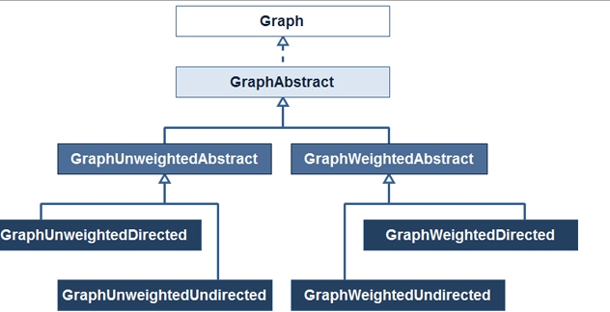

B. Kinds of questions a graph can solve (solve puzzles with only one solution):

a. Delivery routes (FedEx, UPS)

b. travel routes (mapquest, google maps)

c. computer gaming (chess, Wei-Chi)